PIZZA SALES SQL QUERIES
- KPIs
- Total Revenue
SELECT SUM(total_price) AS Total_Revenue from pizza_sales
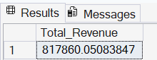

- Avg_Order_Value
select sum(total_price) / count(distinct order_id) as Avg_Order_Value from pizza_sales
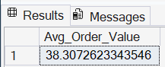

- Total_Pizza_Sold
select sum(quantity) as Total_Pizza_Sold from pizza_sales
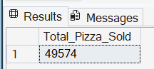

- Total Orders
select count(distinct order_id) as total_orders from pizza_sales
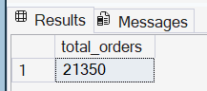

- Avg Pizza Per Order
select Cast(cast(sum(quantity) as decimal(10,2)) / cast(count(distinct order_id) as decimal(10,2)) as Decimal(10,2)) as Avg_Pizza_Per_Order from pizza_sales
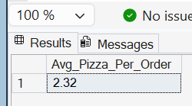

- Total Order by Days of the Week
select datename(dw, order_date) as order_day, count(distinct order_id) as total_orders from pizza_sales
Group by datename(dw, order_date)
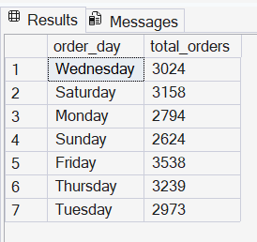
- Total Orders by Months
select datename(month,order_date) as Month_Name, count(distinct order_id) as Total_orders from pizza_sales
Group by datename(month,order_date)
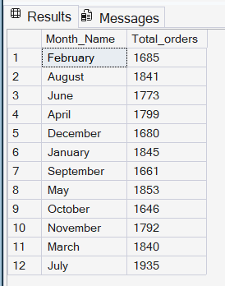 By descending
Order by total_orders desc

- Top 5 Pizza by revenue
SELECT top 5 pizza_name, Sum( total_price) as Total_Revenue from pizza_sales
group by pizza_name
order by Total_Revenue desc
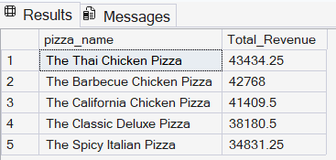

- Bottom 5 Pizza by Revenue
SELECT top 5 pizza_name, cast(Sum( total_price) as decimal(10,2)) as Total_Revenue from pizza_sales
group by pizza_name
order by Total_Revenue asc
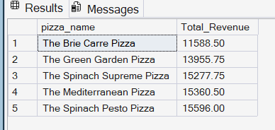

- Top 5 by Quantity
SELECT top 5 pizza_name, Sum(quantity) as Total_Quantity from pizza_sales
group by pizza_name
order by Total_Quantity desc
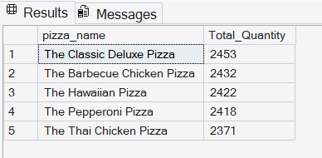

- Bottom 5 by Quantity
SELECT top 5 pizza_name, Sum(quantity) as Total_Quantity from pizza_sales
group by pizza_name
order by Total_Quantity asc
